PHSEP

PROJECT HEALTH SAFETY & ENVIRONMENTAL PLAN

for
XXXXCLIENTXXXXX
Project# XXXXX

TABLE OF CONTENTS
I. HSE Policy 3
II. HSE PROGRAM MANAGEMENT 4
III. HSE COMMITMENT & GOALS 5
IV. ONE SHELL SQUARE PRINCIPAL SAFETY RULES 6
V. RESPONSIBILITY AND ACCOUNTABILITY 7
VI. PROJECT SAFETY COMMUNICATION & LEADERSHIP 14
VII. SUBSTANCE ABUSE POLICY 15
VIII. SUBCONTRACTOR MANAGEMENT 16
IX. DISCIPLINARY ACTION 17
X. TRAINING REQUIREMENTS 17
XI. SECURITY/SITE ACCESS 17
XII. PERSONAL PROTECTIVE EQUIPMENT (PPE) 18
XIII. SAFETY INSPECTIONS AND AUDITS 21
XIV. EMERGENCY RESPONSE 21
XV. INCIDENT REPORTING AND INVESTIGATION 23
XVI. WORK AUTHORIZATION & PERMITS (when required) 24
XVII. FIRE PROTECTION & PREVENTION 25
XVIII. HAZARD COMMUNICATION 26
XIX. LADDERS 28
XX. SITE MANAGEMENT 29
XXI. HOUSEKEEPING 29
XXII. ELECTRICAL SAFETY 30
XXIII. FALL PROTECTION 32
XXIV. SPECIAL REQUIREMENTS 33
XXV. MEDICAL CARE 34
XXVI. KEY PERSONNEL 36
XXVII. APPROVAL 37

HSE Policy

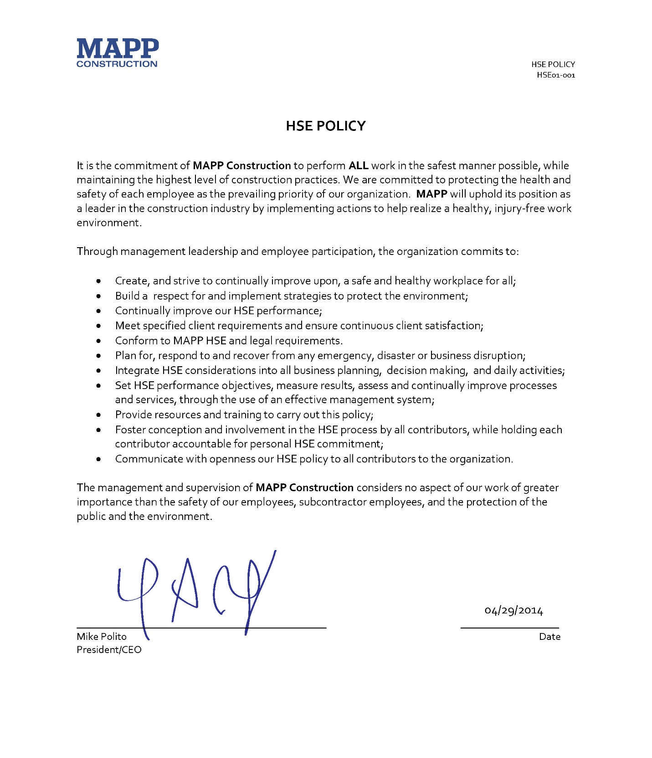

HSE PROGRAM MANAGEMENT

- The purpose of MAPP’s CLIENT Project Health Safety and Environmental Plan (PHSEP) is to establish certain criteria and procedures for the analysis, development, implementation, training, auditing, and evaluation of safety procedures tailored to conditions present and by the work scope for this project. This plan is intended to address certain hazards and to provide management, site supervision, workers, and other contributors with the tools necessary to conduct all construction in a safe and efficient manner. Provisions for this plan have been established through the MAPP’s HSE Management System, CLIENT HSE requirements, OSHA’s General Industry and Construction Regulations, and applicable federal and state regulations.
- Where a CLIENT specific HSE policy has not been implemented, the MAPP Corporate HSE Policy will be the minimum requirement for compliance.
- The PHSEP, as contained herein, will be reviewed on a regular basis, and will be revised as necessary to accommodate changing project conditions, as well as changes in the law.
- This PHSEP shall become part of every construction contract at the Project and shall be considered as a mandatory minimum requirement for all contractors and their subcontractors of all tiers.

HSE COMMITMENT & GOALS
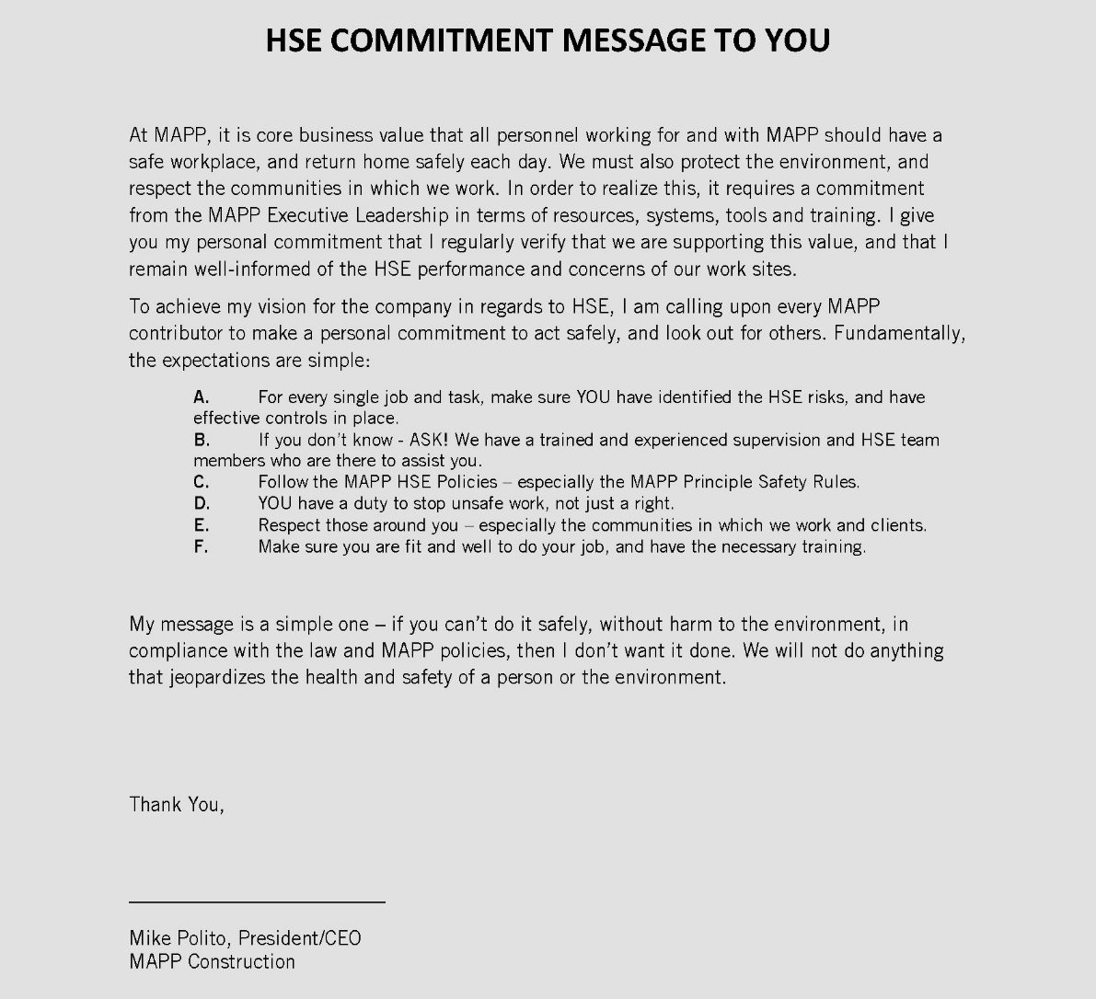

  - MAPP is committed to a zero injury environment. It is our belief that safety is a value, not compromised by cost or schedule. Everyone has the right to go home safely at the end of the day.
  - MAPP’s principal goal is for each project subcontractor to conduct all construction activities with a zero incidence objective. This goal includes not only zero injuries but also zero property damage and environmental incidents.
  - MAPP’s objective is total customer satisfaction achieved by consistently producing a level of quality and productivity that completes a project on or ahead of schedule, within budget, and in compliance with all applicable standards.
  - MAPP is committed to providing its employees, its subcontractors’ employees, and vendors, other on site personnel, clients, and the public with a Drug & Alcohol Free Construction Environment.

PRINCIPAL SAFETY RULES
  - All persons accessing the MAPP project site shall embrace and abide by the mandatory Principal Safety Rules adopted by MAPP. Failure to comply will result in disciplinary action, up to and including removal from the site and disqualification from future work with MAPP for violating employees.

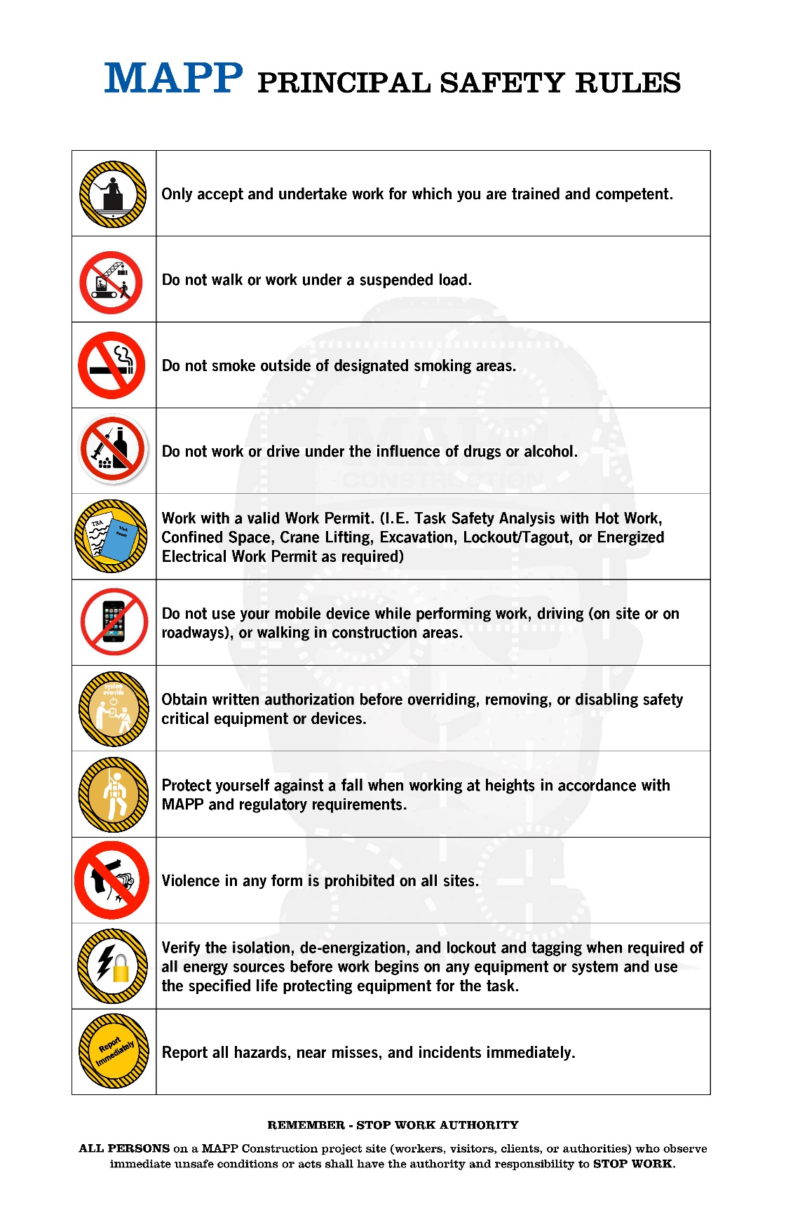

RESPONSIBILITY AND ACCOUNTABILITY
  - Everyone associated with this project must understand their responsibilities with regards to health and safety on this project. With the responsibilities defined, project management, supervision, subcontractors, workers, and visitors will be held accountable for their health and safety performance.
  - GENERAL CONTRACTOR
    - The General Contractor (MAPP) mandates each project employee understand and accept his/her responsibility for performing each task in a manner consistent with the prescribed safe work practices, rules, and all applicable regulations. This mandate includes full compliance with Client’s requirements governing contractor employee conduct while on its premises.
    - The MAPP Project Executive is responsible for the health and safety of all personnel assigned to the CLIENT project. They shall:
        - Assure compliance of the PHSEP with established MAPP HSE-MS standards, MAPP HSE policies, and client requirements.
        - Communicating the company’s goals and objectives to each project employee through site management.
        - Provide adequate budget and resources for implementation of the site HSE program.
        - Exercise accountability, and provide for the delegation of accountability to a responsible manager for the HSE performance of the project.
        - Inform the Corporate Safety Director and Site Superintendent immediately of any factors or problems that could affect safe operations through the duration of the project.
        - Reviewing HSE performance of the project and its personnel to ensure company and project objectives and expectations are met.
        - Regularly attend and participate in Project HSE safety meetings.
        - Review and recognizing good HSE performance by individuals and teams.
        - Participate in accident investigation processes; if necessary.
        - Discuss safety and health as a value-adding topic of discussion at all meetings.
        - Coach others for continuous improvement;
    - The MAPP Project Manager(s), along with Site Superintendent(s) are responsible for the overall safety, health, and environmental program’s performance. However, each subcontractor Project Manager and Superintendent/Foreman are responsible for onsite work activities, which include implementation, enforcement, and administration of safety and health, related activities. The PM is responsible for:
        - The development of a Project HSE Plan (PHSEP) for the project, in coordination with the MAPP Safety Department and all site supervisory employees, and obtaining approval from the Client and the MAPP Corporate Safety Department prior to conducting any on site activities.
        - Promoting safety awareness at all times.
        - Ensure the allocation of funding and resources necessary to meet project HSE goals and objectives.
        - Exercise accountability, and provide for the delegation of accountability to responsible persons for the HSE performance on site.
        - Continuously communicate directly with all site personnel regarding any and all information on safety-related matters and concerns.
        - Conducting at minimum weekly field activity inspections to assure adherence to project safety requirements.
        - Eliminate construction work interruptions by pre-planning and evaluating foreseeable safety issues.
        - Planning and coordinating work activities to avoid personal injury, property damage, and delay of production time.
        - Require that good housekeeping procedures be maintained by all parties throughout the duration of the project.
        - It is the responsibility of the Project Manager to see that all phases of the project are performed according to contract requirements.
        - It is the responsibility of the Project Manager to contact the offending subcontractor and seek corrective actions as may be necessary to achieve contract compliance.
        - Participate and encourage employee participation in the Safety Observation (SOR) behavioral process. Supervision shall perform at minimum one SOR per day, to be submitted to the Project Coordinator.
        - Coordinating with the client and other third parties on HSE matters.
    - The MAPP Site Superintendent(s), along with MAPP Project Manager(s) are responsible for the overall safety, health, and environmental program’s performance. A Superintendent is responsible for:
- Promoting and leading, by example, a proactive safe work environment at all times.
- Perform the review and authorization of daily work plans (TSA) and permits.
- Monitor continuously workers and work group’s performance for quality and adherence to safe work requirements.
- Reporting and participation in the investigation of all incidents to the MAPP HSE and Project Manager.
        - Planning and coordinating work activities to avoid personal injury, property damage, and delay of production time.
        - The preparation and primary deliverer of site safety meetings and site safety orientations;
        - Continuously communicate directly with all site personnel regarding any and all information on safety-related matters and concerns.
- Conducting at minimum weekly field activity inspections to assure adherence to project safety requirements.
- Require that good housekeeping procedures be maintained by all parties throughout the duration of the project.
- Enforce a visitor control program and the overall traffic control plan for pedestrians, vehicular traffic, and construction operations.
- Assist and help lead the site wide weekly safety meeting that is required for all employee attendance.
- Lead, facilitate, and document the weekly Subcontractor HSE Meeting to review project safety related information.
- Collect and maintain Hazard Communication information with the assistance of the Project Coordinator including site HazCom program, SDS's, and inspections of chemical storage areas.
- Lead Pre-Work Assessment (PWA) reviews with subcontractors and other parties to evaluate and update as necessary scopes of work.
- Participate and encourage employee participation in the Safety Observation (SOR) behavioral process. Supervision shall perform at minimum one SOR per day, to be submitted to the Project Coordinator.
- Continuously communicate directly with all site personnel regarding any and all information on safety-related concerns
- In the event of imminent danger situations, supervisors or employees shall discontinue the affected work, contact the MAPP Superintendent and together they shall immediately resolve the situation.
- Maintain detailed records of all project safety related activities.
    - The MAPP Corporate Safety Department will be responsible for ensuring that the site staff has the necessary information to lead a safe worksite. The MAPP Safety Department will:
        - Maintain all MAPP safety documentation records such as: the Corporate OSHA 300 log, master incident investigation files, and MAPP employee safety training records.
        - Provide guidance on the development of the PHSEP.
        - Providing access to and advice regarding HSE laws, regulatory requirements and applicable standards that the company and its operations must meet across the various jurisdictions in which it operates.
        - Issue and promote communications related to safety and health to all projects and personnel.
        - Develop, distribute, review, and maintain MAPP HSE policies and procedures; assist with the development of the CLIENT project HSE policies.
        - Develop, supervise, and coordinate training programs or media, which will increase proficiency in safe work practices and promote safety consciousness.
        - Evaluate the qualifications and training of subcontractor workforce through random subcontractor audits.
        - Periodically inspect the project site to detect potential safety, health and environmental hazards, and recommend corrective or preventative measures where appropriate.
        - Participate in the investigation of incidents, as requested by the site team and lead the serious incident investigation processes for all MAPP projects.
- SUBCONTRACTORS
    - As a condition of the contract, each subcontractor, its agents, supervisors, and employees are expected to conduct their business in a manner which complies with both the letter and the spirit of all environmental and safety work practices, laws, rules, and regulations that govern this project and its employees. This shall include adopting this Project HSE Plan (PHSEP) and the MAPP Substance Abuse Policy and Enforcement Program for this project.
    - Each subcontractor shall retain primary responsibility for the safety of its employees. They will be required to provide safety coverage for their particular work scope.
    - All subcontractors shall designate a competent person to implement and enforce the site specific safety plan.
    - A subcontractor shall have on site a full time qualified and competent foreman/supervisor for every 30 workers assigned to the project site.
    - A subcontractor safety representative will be required once they have and for every 30 employees assigned to the project. This safety representative shall not have any other duties outside of health, safety, and environmental protection.
    - Each subcontractor will submit to MAPP at least one week prior to mobilization a Subcontractor Site Safety Plan (SSSP) that shall describe their work in detail. (See Attachment A - SSSP Guide) This SSSP must provide sufficient assurance to MAPP that the subcontractor has addressed the risks associated with the work, and has addressed preventative or control measures for safety and health hazards. In lieu of completing the SSSP Guide in Attachment A, subcontractors may submit their own site specific safety plan to be reviewed and approved by the MAPP and Client HSE Supervisors. Provisions of the SSSP include:
        - Assurance to MAPP that the work to be performed complies with safety, health, and performance requirements specified in subcontractor documents.
        - Submit general HSE Training verification of OSHA required training required by the PHSEP training requirements. Verification shall include copies of all employees training badges, cards, or cetificates.
        - Designate in all appropriate instances, a “Competent Person” as required by the applicable OSHA standards. Documentation of acceptable training is required.
        - Designate first aid providers on site for the subcontractor. A minimum of one person for every 50 assigned to the project must possess current acceptable first aid training and be on site during all working hours. Documentation of acceptable training is required.
        - Indicate your company's trained and qualified equipment operators as per your scope. Documentation of acceptable training is required.
        - Submit project specific Master Chemical and Substance Inventory and Safety Data Sheets (SDS) for all hazardous chemicals and materials to be used or stored on the project.
        - Describe the construction schedule and methodologies of each work task, including HSE risks, prevention and control measures, equipment, personnel, and lower-tier subcontractors to be used during operations. The use of the Pre Work Assessment (PWA) form is recommended. (HSE65-001). All identified hazards and associated risks shall be eliminated, controlled, or managed to ALARP (as low as reasonably possible).
        - If not utilizing the PWA for work task plan submission, the minimum level of detail for work task plans shall include the following as applicable:
          - Site mobilization details, including delivery and setup of equipment, fuel storage, waste disposal, anticipated training activities, and mobilization activities.
          - Personnel safety planning, craft designations, anticipated crew sizes, and number of crews performing work; types, sizes, and number of pieces of equipment; lower-tiered subcontractor involvement; and testing procedures and requirements.
          - A summary plan for the maintenance, service, inspection, and repairs of onsite equipment or machinery.
          - Methods of compliance with General Conditions, Client requirements, all applicable Federal, State, and Local Laws, and this PHSEP.
          - HSE risk assessment, ranking, and control plans.
          - Shall be developed so individual pages or sections addressing work activities and corresponding health and safety requirements may be lifted, reviewed with Project Team, and utilized for briefing and developing of daily task plans.
    - General subcontractor duties also include those for all employees, as well as the following responsibilities:
        - Effectively communicate and enforce this PHSEP, and Subcontractor Site Safety Plan to each member of their work group prior to beginning work on site and for the duration of the project.
        - Promoting safety awareness at all times.
        - Eliminate work interruptions and related hazards by pre-planning each task and evaluating the risk of all work activities.
        - Allocating manpower, as required, to provide for safe operating procedures on the job.
        - Orient the worker upon hire or assignment to project with respect to:
          - The work group (new worker),
          - General and task specific safety hazards,
          - This PHSEP and subcontractor site safety plans.
        - Assign employees only to tasks for which they are trained and qualified.
        - Adhere to site daily work authorization policies by performing Task Safety Analysis (TSA) and briefings, obtaining special work permits (as required), and participation in behavioral observations that are turned into the Project Team on a daily basis.
        - Require that good housekeeping procedures be maintained by all parties throughout the duration of the project.
        - Subcontractors shall not relinquish or defer responsibility for project safety to its own or subcontractor employees, at any time, under any circumstance.
    - Subcontractor foreman/supervisors and subcontractor HSE Representatives (as applicable) shall additionally:
        - Monitor worker and work group performance for safe work practices.
        - Setting the example by support the project HSE goals, maintaining good housekeeping and eliminating unsafe conditions.
        - Correct any deficiencies, hazardous conditions, or corrective actions assigned to the subcontractor company immediately upon notification and submit verification of completion to the Site HSE Department.
        - Report immediately to the Site Superintendent all incidents, regardless of severity. Support the management of and assist as requested the incident investigation process.
        - Lead by example, and encourage workers to actively participate in the HSE process.
        - Ensure that all equipment, tools, and machinery are inspected and properly maintained.
        - Shall perform a minimum one documented safety observation per day, and submit to the Site HSE Department.
        - Attend the required weekly Subcontractor HSE Meeting to review project safety related information.
- EMPLOYEES
    - All Employee/Worker acceptance, comprehension, and support of the PHSEP and CLIENT HSE policies and procedures is the ultimate key to the success of the HSE program. All employees and workers on site are responsible for:
        - Complying with the requirements of this PHSEP, all MAPP CLIENT HSE standards, policies, and procedures and their SSSP, as applicable, established for his/her safety and health and for preservation of the environment.
        - Carrying out their work in a manner which does not present a risk to themselves, others and the environment.
        - Assisting management and supervision in positive development of their co-worker's attitudes toward HSE and workplace morale.
        - All project employees shall immediately report all incidents (including injuries, illnesses, near misses, environmental impact events, property damage), and unsafe conditions that may exist on the project site, to their supervisor and the Project Team regardless of the severity of the incident or condition.
        - Suggesting improvements and being active in the general improvement of all systems and methods of work to ensure operations are carried out in a personally and environmentally safe, reliable and cost effective way.
        - Correct immediately any imminent danger situations, e.g., exposure to falls from elevations, electrocution hazards, exposure to improperly protected excavations, etc.
        - Notify their supervisor and ask for help if they have an insufficient understanding of any standard, policy, requirement, tool, task, or procedure.
        - Plan your work and try to anticipate, understand, and control or manage any hazards you might encounter.
        - All project employee shall attend all weekly and special project safety meetings.
        - Each project employee will be required to properly use, wear, inspect, and maintain all personal protective equipment, and devices as instructed by their company policy and management, MAPP Project Management, and the Client.
        - All employees shall provide all necessary information to complete accident investigations and fulfill insurance requirements.
        - All employees shall attend a site specific orientation provided by MAPP prior to doing any work on site.
        - All project employees shall understand this Project Health Safety & Environmental Plan (PHSEP) and be required to abide by the provisions therein. Refusal or failure to comply with the Project HSE Plan may result in immediate discharge.
        - Each project employee will have the authority and responsibility to stop any work, which is felt is life threatening or could cause serious bodily harm.
        - All project employees will maintain a clean and safe work area.
- VISITORS
    - All visitors are required to report to the MAPP Construction project field office upon arriving to the project site. Access to the site shall be denied to any individual who does not have justifiable business on the job site.
        - A visitor is a person not routinely (meaning at least 16 hours per week) accessing or performing work on the project, including but not limited to: delivery personnel, consultants, suppliers, sales representatives, inspectors, company management, etc.
        - Requests for tours of the project site shall be carefully screened and limited in frequency and numbers of people. Tours of the site shall be approved by the MAPP Construction project team. MAPP shall establish the time and travel route for any tour. Areas which may present hazards to the tour groups shall be prohibited. The tour's travel route shall be cleared of any tripping hazards, cleaned, and properly protected to avoid potential personal injury. A designated member of the MAPP site team shall guide the approved tours.
        - Whenever possible, advanced notice (usually 24 hours) shall be given to the MAPP Site Superintendent for all visitors intending to enter the project.
        - All visitors shall at least annually sign the Site Safety Visitor Orientation Form (See Attachment B - SSVOF).
        - All visitors must complete all portions of the visitor sign-in log (name, company, cell phone #, destination, contact person, etc.)
        - All visitors shall be escorted at all times while on site by an authorized and designated project team member.
        - Any visitor not complying with site HSE policies will be removed immediately from the project.
        - All personnel, who have not received authorization for entry, have not signed in, or refuses to comply with any portion of the PHSEP shall be required to leave the site immediately. Future admittance to the project may be denied.
        - All persons who refuse to leave the site shall be reported to the local authorities and subject to arrest (No one other than the local authorities shall be allowed to forcibly remove or detain anyone on the project).
        - Any visitor involved in an incident on the project may be subject to drug and alcohol testing, as stated in the Substance Abuse Policy.
        - MAPP, the Client, and Subcontractors will be held responsible for the safety and conduct of their respective visitors.

PROJECT SAFETY COMMUNICATION & LEADERSHIP
  - Weekly Site Safety Meeting - All site personnel must attend a minimum of one weekly safety meeting led and scheduled by the MAPP Project Team. This includes all MAPP, subcontractor, vendor, and Client supplied personnel. The weekly safety meeting should cover job relevant topics each week, and be approximately 15 minutes in length. Safety meeting attendance and information should be documented on the MAPP Meeting Attendance Report Form (HSE-FM-002) and a copy of presented material be kept with the sign-in sheet. Original documentation should be kept onsite by the Site Superintendent and a copy sent to the project coordinator for indexing in PVault.
  - Daily TSA Review - The Subcontractor Foreman will discuss with craft workers the planned work activities, hazards, safe work practices, personal protective equipment needs, and other issues of concern at daily TSA kick off reviews.
- Weekly Subcontractor HSE Meeting – All subcontractors (foreman and/the safety representative) will be required to attend a weekly HSE meeting while they are working on site to review project performance and to identify opportunities to improve the safety process. The MAPP Project team will review the weekly observation trends, open and closed action items, incident and near misses, and safety related concerns. After the office meeting, all attendees will perform a jobsite safety walk.
- Special HSE Meetings - On occasion, a special safety alert, stand down, policy changes, industry alerts or other meeting will need to be shared. A safety meeting should be held with all site personnel to review the information. A Meeting Attendance Report Form must be completed to document the meeting and filed with the other site safety meetings. If requested, a copy of the meeting documentation should be sent to the MAPP Corporate Safety Department.
- A visual workplace board shall be erected and displayed in project common areas, such as break areas, to post required jobsite signage, posters, notices, etc.

SUBSTANCE ABUSE POLICY
  - The use of illegal drugs, on or off duty, is inconsistent with law-abiding behavior expected of all citizens. The use of illegal drugs, or abuse of alcohol or prescription drugs, may impair the ability of employees to perform tasks that are critical to safe work performance. The result is an increase in accidents and failures that pose a serious threat to the safety of all employees, visitors and the general public. Furthermore, employees have the right to work in a drug free environment and to work with persons free from the effects of drugs and alcohol. Employees who abuse alcohol or drugs are a danger to themselves and to other employees.
- In an effort to create a safe and healthful workplace, the project has adopted a Substance Abuse Policy requiring substance abuse testing. Nothing in this policy is intended as a substitute for any company's complete written substance abuse policy. This program is intended as a guide, to establish the minimum requirements for complying with the Client’s requirements for a drug free work place.
- This policy applies to all MAPP, Client, and Subcontractor at any tier, Vendor and other third party employees, including management working on or visiting the CLIENT project.
- The project requires all plans meet at minimum the requirements of the project Drug and Alcohol Free Workplace Policy. (See Attachment C –Drug and Alcohol Free Workplace Policy)
- The following are prohibited on all MAPP projects:
    - Being under the influence of any amount of alcohol or illegal drugs.
    - The use, sale, offer to sell, purchase, transfer, distribution or possession of illegal drugs, drug paraphernalia or alcohol products.
- No employee or prospective employee of a contractor or subcontractor shall be permitted to work on the client’s site of construction unless such employee has acknowledged his understanding in writing of the requirements of the testing program and has submitted to testing as required by this specification.
- Any site employee/visitor who suffers an on-the-job injury requiring off site medical treatment, or following a potentially serious incident, in which safety precautions were violated, unsafe instructions or orders were given, a potentially serious accident occurred were vehicles, equipment or property was damaged, or where unusually careless acts was performed will be tested for drugs and alcohol within three (3) hours of the incident.
- The involved employee/visitor’s employer is responsible for ensuring all persons involved in an incident have a post incident drug & alcohol test and will report the results to MAPP. At a minimum, the drug test will follow current Substance Abuse and Mental
Health Services Administration (SAMHSA) five panel guidelines and the alcohol test will follow Department of Transportation (DOT) guidelines.
- Persons that refuse to test, significantly stall to be tested, are uncooperative with collectors, or attempt to alter a specimen will be considered positive and immediately removed and banned from the project.

SUBCONTRACTOR MANAGEMENT
  - All MAPP Subcontractors will be evaluated through MAPP Subcontractor Prequalification
Process.
      - The Preconstruction Department requires any current or potential subcontractor to begin the pre-qualification process through completion of the Vendor Qualification Form (VQF). The information captured in this form consists of safety, available workforce, insurance, financial history, bonding capacity and references. (See Attachment D – MAPP Vendor Qualification Form & Single Project Limit Continuation Sheet)
      - The information captured on the VQF provides the basis for completing a continuation sheet. The Continuation sheet is used to disqualify, or calculate a Single Project Limit for the subcontractor. Subcontracts valued higher than the vendor’s single project limit cannot be awarded without prior approval from the Risk Management Committee.
      - The Project Manager (PM) will complete a Subcontractor Risk Evaluation (SRE) prior to inviting a subcontractor to bid on the CLIENT Project. Information required to complete the form is pulled from the VQF and the subcontractor’s submitted HSE program. Once the SRE is approved by the appropriate personnel, the subcontractor will be invited to bid the project. (See Attachment E –Subcontractor Risk Evaluation)
      - If the subcontractor does not meet the low risk criteria established in the SRE Qualified Summary, the SRE risk mitigation steps must be met and subcontractor evaluated by the Risk Management Committee.
- Subcontractors will be required to comply with the requirements of this PHSEP and all MAPP and CLIENT site HSE policies.
- Subcontractors are required to provide for evaluation and substance abuse testing for their employees according to the requirements of the project Substance Abuse Policy and will be subject to audit by MAPP.
- Subcontractors will be required to attend weekly a Subcontractor HSE Planning meeting to review project performance and to identify opportunities to improve the safety process.

DISCIPLINARY ACTION
  - Although it is not the intent of this plan to dictate discipline, all site personnel shall be covered by the MAPP Enforcement Policy including subcontractors. The project team should make every effort to work with subcontractors when safety and health violations are observed or reported. When an employee, subcontract employee, or group of employees is noted to be in violation of safety and health policies, this written enforcement program should be enacted. The enforcement of site safety policies is critical in ensuring uniform and safety of all workers on site. This policy will have 4 levels of enforcement. (See Attachment F - Safety Policy Enforcement Form.)

TRAINING REQUIREMENTS
  - Subcontractors shall provide MAPP, as part of the submitted SSSP, a copy of all task specific training verification badges/cards to be eligible to work on site.
  - All workers shall receive a site-specific orientation prior to performing any work on the project. The site-specific orientation is normally 20 minutes in duration and is provided by the MAPP Project Team when the subcontractor mobilizes on site. Once employees have completed the site-specific orientation they will sign the orientation attendance form and receive a hard hat decal to display on their hats for the duration of the project. The summary outline for the site specific safety orientation can be found in (Attachment G – CLIENT/PROJECT Site Orientation Summary.)
- Each subcontractor should be able to demonstrate that their employees have received safety and health training relevant to their scope of work as defined by OSHA. Also, that skilled employees have received and are qualified to perform that work tasks they are assigned to. Employee skills assessment, training records and evidence of record retention must be maintained and made available for audit by the project team or client if requested.
- In conjunction with the SSSP, each contractor shall submit a signed and completed Contractor Employee Compliance Letter which confirms: (See Attachment H – Site Compliance Access Form)
    - That all persons have reviewed, understand, and agree to comply with all requirements in this PHSEP and the Subcontractor Site Safety Plan (which includes the Substance Alcohol Policy).
    - That the contractor agrees that all company employees/representatives have been competently trained and will comply with all federal, state, local, and MAPP HSE policies; prior to beginning any work on the project.
    - Contractor also confirms that all craft personnel have been trained and certified for the work they will be performing; as applicable by regulations, policies, and industry standards.
    - The letter also verifies that a controlled substance screening has been completed prior to assignment for each employee.

PERSONAL PROTECTIVE EQUIPMENT (PPE)
  - Subcontractors are required to utilize appropriate engineering and administrative controls to protect their employees from all recognizable hazards on this project. When implementation of these controls are not feasible, contractors shall issue appropriate personal protective equipment (PPE) for their employees.
  - Each subcontractor is required to furnish necessary PPE for their own employees to cover their subcontracted scope of work and assure that their employees are properly trained on each type of PPE used.
  - The following is the minimum PPE required while in construction work areas. Other PPE may be required due to task specific requirements and hazards. (such as welding, electrical activity, fall arrest systems, etc)
    - Head Protection
      - Approved hard hats include both plastic and fiberglass hats that meet ANSI Z89.1 standards for Type 1, or Type 2, and Class A or Class B shall be worn at all times while in construction areas. This includes by welders when using welding hoods.
      - Metal hard hats (Class C) or bump caps are not approved head protection.
      - Hard hats should not be painted, defaced, or reshaped in any way.
      - No holes or penetrations shall be made in the shell of a hat.
      - Personnel shall not remove the suspension straps or cut/alter them in any way
      - All hard hats should be worn forward facing unless designed by the manufacturer to be worn alternatively.
      - Electrical subcontract workers exposed to currents in excess of 2,000 volts shall be limited to Class B hard hats only.
      - Employees are required to inspect head protection prior to use to ensure that the equipment is in safe condition.
    - Hi-Visibility vests or shirt shall be worn while in construction areas by all persons.
      - The high-visibility article shall be worn as an outer garment;
      - It must be worn to provide three hundred sixty degrees of visibility around the employee.
      - Any worker that is performing duties in close proximity to moving vehicles or near roadways must wear high-visibility clothing that meets or exceeds ANSI 107-2010 specifications.
    - Hearing Protection
      - When feasible engineering and administrative controls fail to reduce sound levels, and sound levels exist above the OSHA permissible exposure limits [85 dBA on a time weighted average]; approved hearing protection equipment must be worn by employees.
      - Hearing protection shall be worn when noise exposure exceeds 85 dBA such as high noise producing tasks to include operating tools such as jackhammers, impact wrenches, etc. , or when working near tools or equipment that produce high noise.
      - Hearing protection can be in the form of ear plugs (with the appropriate Noise Reduction Rating NRR), ear muffs, or the use of both.
      - Wearing double hearing protection (ear plugs and ear muffs simultaneously) can give 3 to 5 decibels more protection than wearing plugs alone.
      - Employees must inspect their hearing protectors prior to use.
    - Foot Protection
      - Sturdy leather work shoes or boots with defined heels shall be worn by all workers.
      - Soft shoes such as tennis shoe type shoes are not acceptable for the job site and their use is prohibited.
      - Safety hard-toe footwear (ANSI Z41.1, or equivalent) is strongly recommended for all personnel.
      - Special-purpose (crush resistant, chemical resistant, puncture resistant, and di-electric) footwear shall be used to provide protection from such hazards.
      - Personnel who perform tasks, which expose them to potential foot and/or leg injury hazards, e. g., work involving jackhammers, ground tampers, etc., shall wear additional foot and leg protection, such as metatarsal and shin guards.
      - Personnel shall be required to inspect foot protection prior to use to ensure that equipment is in good/safe condition and is free of snags, rips, tears, and holes.
    - Eye & Face Protection
      - Safety glasses with rigid side shields (ANSI Z87.1, or equivalent) shall be considered the minimum protection and worn at all times when in construction areas. This includes under welding hoods.
      - Prescription eyewear worn on the jobsite must also be of approved ANSI Z87.1 lenses and side shields, or the individual shall wear equivalent designed eye protection over their prescription lenses.
      - Goggles compliant with ANSI Z87.1, of the correct type for the work task, should not be worn over safety glasses, unless designed for, because the goggle-to-face seal will be diminished.
      - A face shield which complies with ANSI Z-87.1 shall be worn to provide face protection to the employees from flying particles, splashes, or mist.
        - It must be noted that a face shield provides only protection to the face and eyes from direct impact objects, and additional eye protection must be worn in conjunction with a face shield; such as safety glasses or safety goggles.
      - A welding hood with a filtered lens shall be used to provide protection from injurious light radiations produced during electric arc welding.
      - Approved safety glasses with side shields and hard hats shall be worn in conjunction with the welding hood to ensure protection from popping hot slag when the hood is raised and overhead work exposures.
      - The use of darker tinted safety glasses indoors is prohibited.
      - Employees are required to inspect eye and face protection prior to use to ensure the equipment is in safe condition.
    - Hand Protection
      - Personnel will be required to have available at all times, and don appropriate work gloves when performing a work task unless the gloves create a greater hazard for the employee.
      - Gloves, appropriate type for the hazard present, shall worn when hands are exposed to absorption of harmful substances, cuts and lacerations, abrasions, punctures, chemical burns, thermal burns, or harmful temperature extremes.
      - There is no one glove that can provide protection against all potential hand hazards. It is important to select the most appropriate glove for a specific application and to determine how long it can be worn and whether it can be reused.
      - Specific glove types should be identified in the pre work assessment and the daily task analysis.
      - Employees are required to inspect hand protection prior to use to ensure the equipment is in safe condition.
    - All persons exposed or potentially exposed to fall hazards shall comply with the MAPP Fall Protection Policy (HSE39-001). This policy states that anytime employees are working from an unprotected elevation of six feet or more, fall protection should be used. Working as stated above means while traveling, stationary, or at any time exposed to a fall from a surface not protected by approved handrails, guardrails or some other approved fall prevention system.
    - Other specialized PPE shall be worn when task specific hazards require such.
- WORK ATTIRE
    - Pants should fit properly and not have extreme bell bottoms, large cuffs, or excessively frayed bottoms.
    - Tank tops or sleeveless shirts are not allowed, four inch (4") sleeved shirts are required. Long sleeved shirts are required when performing task that requires more protection to the arm area such as grinding, burning, handling chemicals etc.
    - Neckties, gauntlet type gloves, and baggy, loose, or ragged clothing must not be worn around or when working with rotating or moving equipment.
    - The wearing of jewelry such as rings, watchbands, necklaces, earrings, or long scalp hair can cause or contribute to accidents, or interfere with prescribed PPE. Therefore, the wearer shall take the proper precautions. Loose, dangling jewelry will not be allowed. Site Management may require long hair to be tucked away or underneath the hard hat.
    - Any work clothing, which becomes heavily soiled, has visible accumulation of hydrocarbons or other flammable, combustible materials, or particulate matter must be changed.
    - Employees are required to inspect work attire prior to the start of a work task to ensure the attire is in safe condition.
    - Work Attire which is defective, in unsafe condition, or damaged shall not be worn and immediately replaced.

SAFETY INSPECTIONS AND AUDITS
  - All onsite MAPP team members will conduct daily field activity inspections, including TSA evaluations, to ensure HSE compliance; hazard correction and risk review, and adherence to site work policies. Documentation will be submitted and open action items tracked by the MAPP Project Coordinator.
- The MAPP Site Superintendent will perform a Monthly Site HSE Audit to assure adequate protective equipment and systems are in place and maintained.
- ALL open action items will be tracked to closure utilizing the Viewpoint – PM Issue Module. Open action items will be discussed at the weekly OAC and subcontractor HSE meetings.

EMERGENCY RESPONSE
  - All accidents are to be handled by the ranking person present, with whomever is available to assist. The ranking person shall direct someone to notify first-aid personnel, and to call for emergency services as necessary. The Site Superintendent is to be notified as soon as possible can be done without delaying assistance to the injured. He will then take over command of the incident and appropriate action. In accidents resulting in injury to personnel, individuals qualified to administer first aid will assist the injured, stabilize their condition, and will arrange for transportation to a medical treatment facility if further treatment is required.
  - Except when necessary to avoid further injury, or to prevent additional damage to the work, equipment will not be moved, or the position of items, parts, pieces, controls, etc. will not be changed until photographs have been made and notes taken by the MAPP Project Team or the person designated to document the investigation and report. As soon as the Site Superintendent can release the area from this constraint, subcontractors concerned will conduct a thorough clean up and make necessary repairs to return to a normal operation.
  - MAPP will prepare an Emergency Response Plan that addresses any building, area or citywide alarms or work site evacuations, and designate a “safe zone” for personnel accountability. This shall be reviewed with all on-site personnel during orientation. (See Attachment I - Emergency Action Plan)
  - All police, fire, ambulance, hospital, and appropriate management and MAPP emergency numbers shall be conspicuously posted throughout the project in common areas.
  - All companies represented on site will be required to provide a list of emergency numbers for all key on and off site personnel relevant for emergency notification. Subcontractors shall submit their emergency numbers as part of the SSSP. The list shall be kept current and be updated as necessary.
  - All project contractors shall provide trained first aid personnel for their work, with a minimum of one first aid trained provider up to and per 50 employees assigned to the project.
  - Severe Weather
    - The following procedures are intended to prepare the project site in the event of severe weather conditions. Since severe weather may be reasonably anticipated to occur during the duration of the project, yet possibly without significant advance warning, all work activities and job site conditions must be planned with a concern for emergency preparations.
    - Upon notification of a Severe Weather Watch or Warning by the U.S. Weather Bureau, the following actions are to be initiated.
      - Each contractor having on-site generators, which are fuel-powered, are requested to notify the Site Superintendent of the numbers and wattage. Generators may be needed to provide temporary power for rescue or clean-up activities.
      - All unnecessary tools, material, and equipment shall be removed from the project site. Particular attention needs to be given to picking up scrap materials and hauling or covering trash containers.
      - Sufficient flashlights, batteries, and bulbs shall be provided to assigned emergency response personnel. A supply of fresh batteries shall be maintained at the project for use in an emergency response.
- Environmental Spill
    - In the event of a spill of environmentally damaging materials, immediate response is required to prevent or minimize the impact this event will have upon the environment and the public welfare. All personnel shall continue to observe standard precautions for handling the materials as detailed in the manufacturer’s product Safety Data Sheet (SDS), including the use of personal protective equipment. The following general procedures apply to the immediate response, which must be initiated:
      - Immediately, all personnel in the immediate area of the release shall be alerted to the hazardous material and the nature of the immediate danger to themselves and the environment. As soon as possible, the Site Superintendent shall be notified and requested to initiate emergency containment and clean up procedures.
      - The Local Fire Department shall be notified if necessary to mobilize their hazardous materials response units and shall be given the necessary information regarding the materials that were released.
      - If safe to do so, every effort shall be made to contain the materials within berms, by absorbent materials, or through other appropriate means, until proper handling and disposal personnel may be mobilized at the site. Particular attention needs to be taken to avoid contamination of surface water, storm sewers, sanitary sewers, occupied spaces, plants and animals.
      - All non-essential personnel shall be removed and/or kept back from the area.
      - The Site Superintendent shall make a full investigation and file an Incident Report with the MAPP Corporate HSE Department within twenty-four (24) hours of the occurrence.
      - If required, as soon as the environmental remediation contractor has cleared the site, the Site Superintendent will release the area for contractors concerned to clean up and make necessary repairs to return to a normal operation.

INCIDENT REPORTING AND INVESTIGATION

  - All incidents, regardless of perceived severity, must be reported to the MAPP Site Superintendent or MAPP Project Team member after the occurrence and prior to seeking medical treatment unless in cases of life threatening injuries. This includes damage to property, construction equipment, and vehicle-related incidents. Priority items include care for the injured, establishing control over the accident scene, and notification of proper project personnel.
  - After priority items have been accomplished, the MAPP Site Superintendent or designated person shall obtain as much preliminary information as possible. Preliminary information should include who was involved, the nature and extent of the injury, what happened, where it happened, how it happened and the names of any witnesses. If practical, take photos of the scene as soon as possible before any conditions are altered.
  - All applicable documentation (Incident Report Form, Injured Employee Statement, etc. (See HSE24-001) will be completed and submitted to the MAPP HSE Department for classification of incident and further investigation, if necessary.
  - The following steps will be taken to report an injury requiring medical treatment:
    - Obtain and record all pertinent information such as: Employee name, social security number, address, age, type and extent of injury, what happened, where, and when it happened.
    - A controlling employer representative will be required to accompany all injured employee(s) to the designated medical facility. Controlling Employers shall certify any employee(s) involved in an incident tested negative for drugs or alcohol prior to allowing them to return to the project premises.
  - The MAPP Incident Investigation Form must be completed for all incidents, injuries, and work-related illnesses. A preliminary report shall be forwarded to the MAPP Corporate HSE Department, the Project Management Team, and Client HSE Representative within twenty-four hours of the occurrence.
  - After initial first repose duties are complete, the HSE Team will determine if further Root Cause Analysis is required based on severity of incident or clients request. The Root Cause Analysis Guidance shall be used for all incidents. (RCA-GUI-001) Corrective Actions resulting from formal Root Cause Analysis will be distributed to persons is and subcontractor involved. The Project Team will be responsible for stewardship of corrective actions on all levels of management.
  - “Near Miss Reports” will be prepared for each incident in which a condition exists or an act is carried out that had the potential for an injury or health exposure to take place. The difference between a near miss and an incident is often a fraction of a second or an inch. Each near miss will be documented on the Near Miss Report Form (HSE24-005) and submitted to the Project Team so they can be brought up in the weekly safety meetings for learning purposes.
  - A first aid kit will be available in the MAPP Construction office at all times for minor injuries. Each project subcontractor shall have sufficient medical supplies available at the job site to supply first aid service to their injured employees.

WORK AUTHORIZATION & PERMITS (when required)
  - Authorization to Work - No work will be conducted on site without a MAPP work authorization specific to the task that is to be performed that day. The Task Safety Analysis (TSA) shall serve as the daily work authorization for this project. All TSA’s shall be developed and documented per the TSA Policy (HSE25-001) by each work crew prior to beginning any work task each morning. The MAPP Superintendent, or their designees, shall review and sign off on all TSA’s to authorize the start of work. NOTE: NO WORK SHALL BEGIN UNTIL THE TSA HAS BEEN REVIEWED BY BOTH AUTHORIZING PARTIES. (See Attachment J – Task Safety Analysis Form)
- Hot Work Permit - A task specific Hot Work permit will be required for any operation involving open flames or that has the potential for producing heat and/or sparks. The permit must be completed and authorized by the MAPP Superintendent, or their designee. Hot Work includes, but is not limited to: Brazing, Torch Cutting, Grinding, Soldering, and Welding. (See Attachment K – Hot Work Permit)
- Confined Space Work Permit - A Confined Space Work Permit shall be completed and authorized by the MAPP Superintendent, or their designee, for all areas and conditions identified as a permit required confined space. (See Attachment L – Confined Space Permit)
    - "Confined space" means a space that:
        - Is large enough and so configured that an employee can bodily enter and perform assigned work; and
        - Has limited or restricted means for entry or exit (for example, tanks, vessels, silos, storage bins, hoppers, vaults, and pits are spaces that may have limited means of entry.)
        - Is not designed for continuous employee occupancy
    - A permit required confined space is a confined space that has one or more of the following characteristics:
        - Contains or has a potential to contain a hazardous atmosphere;
        - Contains a material that has the potential for engulfing an entrant;
        - Has an internal configuration such that an entrant could be trapped or asphyxiated by inwardly converging walls or by a floor which slopes downward and tapers to a smaller cross-section;
        - Contains any other recognized serious safety or health hazard.
    - The client shall furnish MAPP with a list of all known confined spaces and their evaluations that currently exist within the building prior to mobilization.
    - Before working in any confined space, a competent person will determine what hazards exist. Any operating system or equipment will be locked out and tagged to prevent accidental operation.
    - All confined spaces shall be considered “Permit Required” unless the subcontractor can prove otherwise. Refer to OSHA 29 CFR 1910.146 for further direction. All subcontractors shall comply with the requirements of the MAPP Confined Space policy. (HSE09-001)
    - All employees working in a confined space must have documented training submitted to MAPP Confined Space Entrant, Confined Space Supervisor, and Confined Space Attendant training as necessary for the task prior to performing any work. Verification of training and competency documentation shall be made provided to MAPP as part of the SSSP.

- Lockout/Tagout Permit
      - MAPP employees do not perform work on energized electrical systems, and any subcontractor performing this type of work shall be required to submit for approval a Lockout/Tagout (LOTO) Program meeting or exceeding the MAPP LOTO policy. (HSE28-001)
      - The MAPP LOTO policy has been implemented to ensure that workers are not exposed to the hazards from moving machinery or equipment and those hazards posed by an energized source (pneumatic, steam, hydraulic, electrical, chemical, etc.). Any task that will involve the locking and/or tagging of sources shall submit a Lockout Tagout Permit to be authorized by the Site Superintendent. (See Attachment M – Lockout Tagout Permit)
      - Safety locks and tags will be applied to all circuits, switches, valves, isolating devices, and any other energy sources to ensure equipment, machinery, or processes that have been considered functioning, charged, or could otherwise be operable have been rendered non-operational or de-energized.
      - If device, valve, switch, control or piece of equipment is locked out, a danger tag shall be attached. Note: No device, valve, switch, control or piece of equipment shall be operated with a danger tag and/or lockout attached regardless of circumstances!
      - No person will remove another worker’s safety lock or attempt to energize any piece of equipment, machinery or process that has been locked out and tagged.
- Energized Electrical Work Permit - An Energized Electrical Work (EEW) Permit must be completed in addition to the daily TSA by any subcontractor performing work on energized equipment. The controlling subcontractor must have in place a program and planning tool that meets or exceeds the MAPP EEW policy. (HSE12-002) (See Attachment N – Energized Electrical Work Permit)
    - Any and all sound methods should be utilized to de-energize equipment prior to beginning of work if possible.
    - No work will be performed on any energized electrical circuit, bussbars, equipment, or panel sunless an approved written work plan is developed in accordance with Chapter 1 of NFPA 70E and submitted to the Project Team for review prior to performance of work.
    - All EEW and applicable permits must be submitted at least 3 days prior to the work being performed.
    - Verification of training and competency documentation for all qualified electrical workers shall be made provided to MAPP as part of the SSSP.
- Excavation Permit – ANY excavation (if required for this project) will require a Daily Excavation Permit for any operation that creates an excavation or trench. (See Attachment O – Excavation Permit)
    - The permit must be completed and authorized by the MAPP Superintendent, or their designee.
    - Excavations be inspected daily prior to use, or when changes occur by a designated competent person. Any subcontractor that should need to excavate material is required to have a competent person to perform the documented inspection and complete the work permit. Verification of competent person training and competency documentation shall be made provided to MAPP as part of the SSSP.

FIRE PROTECTION & PREVENTION
  - Fire prevention is one of the most important concerns for construction in occupied buildings. Each subcontractor shall take all necessary precautions required to prevent fires as a result of their operations.
  - All subcontractors and project personnel shall comply with the fire prevention best practices.
  - For all hot work, task specific Hot Work Permits are required.
  - The subcontractor will have the responsibility to identify what precautions are necessary and be responsible for those precautions will be documented on the permit issued.
  - All subcontractors shall supply and maintain sufficient fire protection equipment and personnel trained in the use of such equipment for their contracted scope of work.
  - Common area fire extinguishers will be placed in conspicuous areas throughout the work site so they are readily available to all employees.
  - All subcontractors are responsible to supply and maintain all necessary fire extinguishers and/or fire watches as required and for all hot work, cutting, or welding operations. Subcontractors may not rely upon the availability of MAPP’s or the Clients firefighting equipment in meeting this requirement.
  - Portable heaters which are used in the work areas shall be approved units complete with controls and have all required safety devices in proper working condition.
  - All flammable and combustible materials, including gas cylinders and portable gas containers, shall be properly stored, piled, protected and handled with due regard to their fire characteristics and potential environmental hazards.
  - All flammable and combustible material shall be kept only in locations as directed by the Project Team.
  - All flammable liquids must be stored outside the existing building in an approved manner, and dispensed only into acceptable safety containers while the containers are electrically bonded.
  - Compressed gases shall be stored in isolated areas outside the building and be securely segregated by type of gas.
  - Combustible refuse and debris will be removed daily and legally disposed of offsite. The burning of refuse/debris of any kind is strictly prohibited. There will be no open fires at the job site.
  - Bulk storage of volatile liquids shall not be allowed within a building at any time.
  - The operation and maintenance of temporary heating equipment shall not create a fire hazard. The use of solid fuel salamanders is prohibited. Only smokeless fuels shall be used for heating purposes. Sufficient quantities of fresh air ventilation shall be maintained to assure the health and safety of all personnel.
  - No storage of liquid petroleum gas will be permitted within a finished building at any time. Storage of liquefied petroleum gas outside the building shall comply with all applicable rules and regulations of governing authorities. All liquefied petroleum gas containers shall be secured in the upright position and protected from external damage.
  - No matches or open flames will be permitted within 50 feet of the area where flammable liquids or gases are used, transferred or stored unless conditions warrant greater clearances.
  - Smoking is not permitted anywhere inside the One Shell Square Building. Smoking is only allowed in exterior designated smoking areas.
  - Each subcontractor will take the necessary precautions when welding or burning above walls to assure that full protection is maintained on both sides of the wall and that areas below are protected.

HAZARD COMMUNICATION
  - All subcontractors involved with this project are required to obtain information on any chemicals that are intended to be used onsite, take steps to reduce exposures, substitute less hazardous materials, and establish proper work practices. These efforts will help prevent the occurrence of work related illnesses and injuries caused by chemicals. Most chemicals/substances used in the workplace have some hazard potential, and thus will be covered by this requirement.
  - Written Program
    - Each subcontractor on site must have a written hazard communication program that addresses how information on hazardous chemicals will be provided to their exposed employees. A copy of which will be provided to MAPP as part of the prequalification process.
    - The written program must describe how the requirements for labels and other forms of warning, safety data sheets, and how employee information and training are going to be met.
  - Identify Hazardous Chemicals/Substances
    - All contractors must prepare a list of hazardous chemicals/substances they plan to bring to the site and submit as part of their SSSP.
  - Labels and Other Forms of Warning
    - All containers of hazardous chemicals must be labeled, tagged, or marked with the identity of the material and appropriate hazard warnings.
  - Safety Data Sheets
    - Contractors must have and submit as part of their SSSP an SDS for each hazardous chemical that they use on site.
    - SDS's must be readily accessible to employees when they are in their work areas during their work shifts.
    - Employees shall not use any chemicals for which the contractor has not received an SDS. The SDS provides information needed to ensure proper protective measures are implemented prior to exposure.
  - Employee Information and Training
    - Each employee who may be "exposed" to hazardous chemicals when working must be provided information and trained prior to initial assignment to work with a hazardous chemical, and whenever the hazard changes prior to arriving to the project site.
    - "Exposure" or "exposed" means "an employee is subjected to a hazardous chemical in the course of employment through any route of entry (inhalation, ingestion, skin contact or absorption, etc.) and includes potential (e.g., accidental or possible) exposure."
    - Every worker on this project shall receive instruction from their employer prior to being assigned to work on the physical and health hazards and procedures to protect against those hazards. Included in the procedures are engineering and administrative controls, personal protective equipment, and emergency instructions for accidental exposure, emergency evacuations, or spill containment of the hazardous chemical or substance.
  - MAPP Hazard Communication Plan
    - The MAPP Hazard Communication Program is applicable to all subcontractors, vendors, and parties bringing hazardous chemicals onto the site. (HSE19-001)
    - This is a project specific Hazard Communication Plan ensuring that information on hazardous chemicals and substances is communicated to workers in accordance with OSHA 29 CFR 1926.59.
    - An inventory of known hazardous chemicals and substances used on this project has been established on the Master Chemical and Substance Inventory which is located and can be reviewed at: Project Site HSE Office.
    - A copy of the Safety Data Sheets (SDS) for known hazardous chemicals and substances used on this project are located and can be reviewed at: Project Site HSE Office.
    - If a copy of a SDS cannot be located, contact your Project Manager, Superintendent, Foreman, or MAPP Representative.
    - Subcontractor project management and first line supervision are responsible for obtaining SDS and ensuring they are received prior to, or at the time of delivery of, a hazardous chemical.
    - Hazardous chemicals will be properly labeled in accordance with the SDS. Containers that hazardous chemicals have been transferred into for use during a
    - All workers shall be trained, as part of the site orientation, on the MAPP Hazard Communication Program, the location of the Hazardous Chemical and Substance Inventory list, the location of the Safety Data Sheets, and labeling requirements.
    - When new hazardous chemicals or substances are introduced into the work environment, workers will be informed of the physical and health hazards.

LADDERS
  - The purpose of this safety policy is to outline the proper use and care of portable ladders on site. Scaffold ladders are addressed in the scaffolding procedure.
- Personnel using ladders will be responsible for inspecting them before use and reporting any defective ladders to their supervisor. These ladders will be taken out of service immediately and destroyed if repair is not feasible.
- Subcontractors shall inspect ladders prior to assignment on the project and at least quarterly thereafter. The inspection will include the rungs, feet, lanyard (for extension ladders), side rails, and rivets.
    - Ladders with broken or missing steps, rungs or cleats, broken side rails or other faulty parts will not be used. A "DANGER, DO NOT USE" tag must be attached.
    - Ladders that have been inspected and safe to use will be identified using a quarterly color code inspection system.
    - All items shall be marked with current quarter colored electrical tape for the first quarter of the project. Subsequent quarters shall be marked as followed, and then repeated annually:
        - October – December Orange
        - January – March Red
        - April – June Green
        - July – September White
- All personnel shall face the ladder while ascending or descending.
- All personnel shall have their hands free of material while climbing ladders. Hand-lines shall be used to raise or lower materials as needed.
- Portable ladders shall be classified as:
    - Portable Ladders: can be either straight (fixed heights, not taller than 12 feet), or extension (two sections or more combined to reach maximum height).
    - Stepladders: folding type opening ladders that are self-supporting.
- All portable ladders will be identified by contractor name, properly stored at their assigned location when not in use, and kept in good, clean condition.
- All ladders shall be equipped with safety feet and both feet of the extension ladder and the feet of a stepladder shall rest on solid support and be at the same level.
- Ladders shall not be placed in front of doors unless the door is locked, roped off, or guarded.
- Tops of ordinary types of stepladders shall not be used as steps or work platforms. All ladders shall be of sufficient length so that work can be performed while at or below the third rung of the ladder from the top or as recommended by the ladder manufacturer (as labeled on ladder).
- All portable ladders, other than stepladders, will be placed on the ground or other support so that the distance from the base of the ladder to a line dropped vertically from the top support is approximately one-fourth of the length of the ladder. Example: A 16 foot ladder shall be placed so that the bottom is four feet away from the wall.
- All portable ladders shall be secured before starting a job. Another employee shall hold the bottom of the extension ladder while the ladder is being tied off or secured.
- All ladders used for access to another level shall be of sufficient length so that the top is at least 3 feet above the upper landing.
- Ladders shall rest on solid support and the feet shall be level. Boxes, barrels or other unstable bases will not be used to obtain additional height.
- Makeshift ladders are PROHIBITED.
- Stepladders (folding ladders) shall not be used as straight ladders. When using a stepladder, make sure the spreader braces are locked to prevent collapse.
- Only one employee shall be on a ladder at a time, except in extreme emergency, or if designed by the manufacturer to be used in such a manner.
- Rungs of ladders shall be kept free of grease and oil.
- Do not lean to outside with a shoulder being more than 12 inches beyond the side rail while on a ladder.
- When it is necessary to do work requiring the release of both hands from an extension ladder, fall protection shall be used. Fall protection shall be secured to a structure of adequate strength for the purpose. Do not secure to the ladder.
- Tools shall not be used in a position that will transmit an extensive downward force to the ladder, causing rung or step failure.
- Only when the user is standing on the ground, at the base of the extension ladder, shall adjustments to the ladder be made. Adjustments to extension ladders shall not be attempted while the ladder is occupied.
- At the end of the workday, ladders shall be moved from the work areas so as not to create a tripping or bumping hazard. Return the ladders to proper storage areas.

SITE MANAGEMENT
  - Subcontractors are required the affected subcontractor to provide proper flagmen, signs, barricades, lights, etc. for convenience and direction of public traffic around the building work areas. The necessary authorities will be notified and local regulations will be conformed to if it becomes essential for public traffic to be delayed or diverted in any way.
  - All subcontractors will ensure that the perimeter of the site and building is accessible for any type of emergency vehicle by disposing of waste materials and proper storage of materials.
  - Construction parking will be reviewed in the orientation of employees. MAPP will adhere to all local regulations in planning out proper parking areas and, if necessary, areas will be roped and barricaded.
  - The blocking of entrances and/or exits of the job site is prohibited. Vehicles found in violation will be towed at owner’s expense.

HOUSEKEEPING
  - All project contractors shall be responsible for maintaining a work site free of refuse and unwanted debris, and shall leave areas broom clean. Proper facilities will be made available to all employees to dispose of rubbish material from trailers, work areas, etc. There is absolutely “NO BURNING” of refuse at the site.
- All work areas and finished areas will be maintained for proper work continuation and walkthroughs, if necessary. Daily cleaning of work areas will be mandated and random inspection confirmation of daily housekeeping.

ELECTRICAL SAFETY
  - Contractors shall ensure that electrical equipment is free from recognized hazards that are likely to cause death or serious physical harm to employees. Electrical equipment and installations used to provide electric power and light at the job site shall meet all OSHA and NEC regulations.
- Examination, Installation and Use of Equipment.
- Before installation or use, electrical equipment shall be examined to ensure that its operation shall not constitute safety hazard to employees. Such equipment shall be examined for the following characteristics:
    - Suitability for installation and use in conformity with the provisions of all applicable regulations. A listing, labeling, or certification may evidence suitability of equipment for an identified purpose for the identified purpose.
    - Mechanical strength and durability. For parts designed to enclose and protect other equipment, this includes the adequacy of the protection thus provided.
    - Electrical insulation.
    - Heating effects under conditions of use.
    - Arcing effects.
    - Classification by type, size, voltage, current capacity, and specific use.
    - Other factors that contribute to the practical safeguarding of employees who use or are likely to come in contact with the equipment.
- Guarding
    - Live parts of electric equipment operating at 50 volts or more shall be guarded against accidental contact. Guarding of live parts shall be accomplished as follows:
      - Location in a cabinet, room, vault, or similar enclosure accessible only to qualified persons.
      - Use of permanent, substantial partitions or screens to exclude unqualified persons.
      - Location on a suitable balcony, gallery, or platform elevated and arranged to exclude unqualified persons.
      - Elevation of eight feet or more above the floor.
      - Entrance to rooms and other guarded locations containing exposed live parts must be marked with conspicuous warning signs forbidding unqualified persons to enter.
      - Electric installations that are over 600 volts and that are open to unqualified persons must be made with metal enclosed equipment or enclosed in a vault or area controlled by a lock. In addition, equipment must be marked with appropriate caution signs.
- Grounding of Equipment Connected by Cord and Plug.
    - Exposed non-current carrying metal parts of cord and plug connected equipment that may become energized shall be protected in the following situations:
      - In a hazardous location.
      - When operated at over 150 volts to ground, except for guarded motors and metal frames of electrically heated appliances if the appliance frames are permanently and effectively insulated from ground.
      - When one of the types of equipment listed below.
        - Hand held motor operated tools.
        - Cord and plug connected equipment used in damp or wet locations or by employees standing on the ground or on metal floors or working inside metal tanks or boilers.
        - Portable and mobile X ray and associated equipment.
        - Tools likely to be used in wet and/or conductive locations.
        - Portable hand lamps.
- Safety Related Work Practices
    - Protection of Employees
      - Contractors shall not permit their employees to work near any part of an electric power circuit that the employees could contact in the course of work, unless such employees are protected against shock by de-energizing the circuit and grounding it or by guarding it effectively by insulation or other means.
      - Where the exact location of underground electric power lines is known, employees using jack hammers or hand tools that may contact a line must be provided with insulated protective gloves.
      - Even before work is begun, the contractor must determine by inquiry, observation, or instruments where any part of an exposed or concealed energized electric power circuit is located. This is necessary because a person, tool or machine could come into physical contact with the electric power circuit.
      - Contractors shall advise their employees of the location of such lines, the hazards involved and protective measures to be taken as well as to post and maintain proper warning signs.
    - Passageways and Open Spaces
      - Contractors shall provide barriers or other means of guarding to ensure that workspace for electrical equipment will not be used as a passageway during the time when energized parts of electrical equipment are exposed.
      - Walkways and similar working spaces must be kept clear of electric cords.
    - Lockout and Tagging of Circuits
      - Contractors shall place locks and tags on controls that are to be deactivated during the course of work on energized or de energized equipment or circuits.
      - Equipment or circuits that are de energized shall be rendered inoperative and have locks and tags attached at all points where such equipment or circuits can be energized.
      - MAPP LOTO policy. (HSE28-001)
- Ground Fault Circuit Interrupters
    - Contractors shall use approved ground fault circuit interrupters for all 120 volt, single phase, 15 and 20 ampere receptacle outlets on construction sites, which are not a part of the permanent wiring of the building or structure, and which are in use by their employees.
    - Receptacles on the ends of extension cords are not part of the permanent wiring and, therefore, must be protected by GFCl's whether or not the extension cord is plugged into a permanent wiring.
    - These GFCI's monitor the current to the load for leakage to ground. When this leakage exceeds 5 mA ± I mA, the GFCl interrupts the current. They are designed to trip quickly enough to prevent electrocution.
    - Subcontractors shall have in place approved program for testing GFCl's. All records shall be made available for inspection at any time.
    - This protection is required in addition to, not as a substitute for, the grounding requirements of OSHA safety and health rules and regulations as specified in 29 CFR 1926.
- Tool and Equipment Inspection
    - Subcontractors shall perform a documented inspection of all power tools and temporary power cords prior to assignment on the project and at least quarterly thereafter.
    - Visual inspection of tools and equipment are required prior to each use and shall include:
      - General condition
      - Plugs and caps, and presence of ground prong
      - Electrical cord sets
      - External defects, and missing parts
      - Defective tools shall be tagged with a “Danger, Do Not Use” tag, taken out of service and placed in a secured location until they are repaired or destroyed.
    - Tools and equipment that have been inspected and safe to use will be identified using a quarterly color code inspection system.
      - All items shall be marked with orange electrical tape for the first quarter of the project. Subsequent quarters shall be marked as followed, and then repeated annually:
        - October – December Orange
        - January – March Red
        - April – June Green
        - July – September White

FALL PROTECTION
  - Fall protection equipment and temporary work platforms shall be inspected and erected by competent persons designated in the SSSP.
  - Engineered systems to alleviate fall potential shall be the preferred method. The safest means of worker access for overhead work (e.g., rolling scaffolds, mechanical lifts, platform ladders, etc.) shall be considered as alternatives to the use of portable ladders.
  - If ladders are used, then the top of all straight and extension ladders shall be tied to a substantial anchor point before use; a second worker must hold the ladder until the tie-off is secure. The top three steps on any step ladder shall not be used at any time. (HSE39-001)
  - These standards establish means to analyze elevated work tasks and determine appropriate personnel protection against fall hazards.
  - All contractors whose employees may be exposed to falls of greater than 6 feet must present an approved plan, that must be reviewed before work at elevated height could commence on site.
  - MAPP requires that each employee be protected from fall hazards, above 6 feet, by a guardrail system, safety net system, or personal fall arrest system. This includes:
    - Leading Edges – Each employee shall be protected by a fall protection system when constructing a leading edge 6 feet or more above a lower level.
    - Hoist Area – Each employee in a hoist area shall be protected from falling 6 feet or more to a lower level.
    - Holes – All holes on a walking/working surface shall be covered to protect from tripping and falling through. Those holes which expose a fall to a lower level 6 feet or more require a guardrail system.
    - Guardrails, fencing, or barricades shall protect each employee at the edge of an excavation 6 feet or more in depth.

SPECIAL REQUIREMENTS
  - Mobile Equipment Operator - Only authorized and qualified personnel may operate equipment or vehicles, including on public roads. Copies of operator certifications should be provided to the MAPP Project Team as part of the SSSP, or prior to the delivery or use of any mobile equipment on site.
- Tools and Equipment – Only trained and authorized employees will operate tools and equipment. All tools and equipment shall be inspected prior to each use. Mobile equipment such as cranes, aerial lifts, welding machines, forklifts, etc., must be inspected and documented on a daily basis. (See Attachment P - Equipment Inspection Checklist)
- No chemical waste, including paint, shall be disposed of in project dumpsters. All paint shall be removed from the site and disposed of according by the responsible subcontractor.
- Communication/Radios – Supervisory personnel shall use cellular phones as their primary means of communication for this project. MAPP Project Team Members and Subcontractor foreman are the only employees authorized to have and use cell phones while on the project site inside the construction areas. All cell phone usage shall be done in a safe area while not working or walking. No cell phone can be used by anyone while operating tools or equipment.
- Safety Observation Report (SOR) – All site personnel shall use SOR’s on a continuous basis to identify, communicate, correct and document unsafe and safe behaviors and conditions. (See Attachment Q - Safety Observation Report Form)
    - The Safety Observation process will engage site personnel to identify potential workplace hazards and unsafe actions of workers as well as for identifying and documenting safe acts and safe workplace conditions. The SOR is a proactive process designed to identify, document, and change unsafe conditions and unsafe behaviors through supervisor and employee involvement.
    - Observations may be conducted by individuals or teams of workers. Observers will monitor work in progress for safe or unsafe acts and safe or unsafe conditions.
    - Observations can include any number of workers for any length of time or workplace conditions.
    - Open and constructive communication between the observer(s) and worker(s) is an important for the success of a SOR. Unsafe acts and unsafe conditions should be discussed and resolved on the spot, if possible. Safe work practices should likewise be identified and positively reinforced through compliment and praise.
    - If imminent danger situations are encountered, work must be immediately stopped and workers removed from the hazard, the hazard abated, and a thorough investigation conducted.
    - It is important that all deficiencies reported have documented corrective actions, the majority of which should be implemented at the time the observation is made. NOTE: Some corrective actions may require a period of time to resolve if, for instance, client involvement is required, equipment must be ordered, etc.; therefore, an open issue log will be kept to document the final close-out or completion of such actions.
    - The MAPP Site Safety Representative will gather and compile SOR data, generate reports, and develop trends to provide feedback to employees and the project team. These reports will help in the development of special emphasis programs designed to highlight positive behaviors and work practices and to address the specific types of deficiency trends.
    - Supervisory personnel should complete at minimum one SOR per day and craft personnel shall complete one SORs per week.
- Any suggestion to improve the safety of the project can be submitted using the Safety Suggestion Form. All ideas will be reviewed by the MAPP Project Team and implemented if approved. (See Attachment R - Safety Suggestion Form)

MEDICAL CARE
  - MAPP and its Subcontractors are responsible for providing /first aid to their employees. A first aid station will be established for minor first aid cases. Assistance will be given if necessary by trained personnel. All personnel involved in an incident requiring off site medical treatment will be treated using project designated medical facilities listed below.
  - Advanced medical response will be provided by calling 911, city ambulance providers, and the project designated emergency treatment hospital.

- MAPP & Subcontractor Occupational Medical Provider
CHANGE MAP
NAME | ADDRESS | PHONE NUMBERS
Clinic:  Prime Occupational Medicine | 303 W Judge Perez Dr,  Chalmette, LA 70043 | Ph: (225) 749-5750 Fax: (504) 570-6353

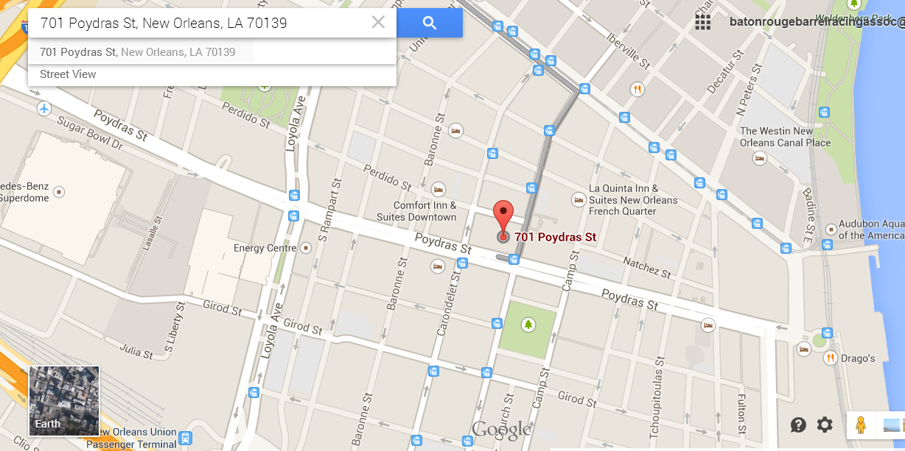

MAP 2 (Occupational Clinic)
CHANGE MAP

MAP 3 (Emergency Medical)
CHANGE MAP
Emergency/Hospital:  Tulane University Hospital | 1415 Tulane Ave  New Orleans, LA 70112 | (504) 988-5344

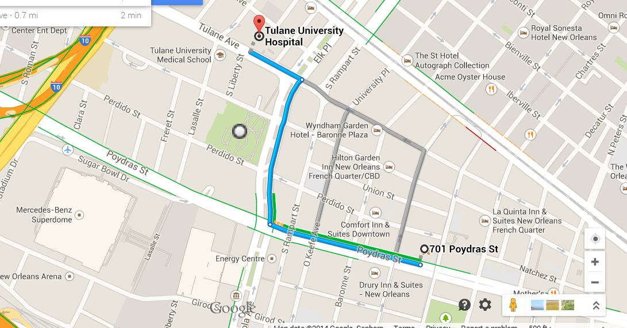

KEY PERSONNEL

CLIENT
xxxxxxxxxxxxxxxxxx | Project Director
 | Sr. Project Manager
 | Project Manager
GENERAL CONTRACTOR
MAPP Construction, LLC | Account Executive
Xxxxxxxxx
Xxxxxxxxx

 | Project Executive
 | Superintendent
 | Project Manager
 | Texas Safety Supervisor | Jose Rodriguez  safety@mappconstruction.com
 | Corporate Safety Director | Anna Holland  aholland@mappconstruction.com  225-266-7525
ARCHITECT
xxxxxxxxxxxxxxxx

APPROVAL

Project Superintendent Approval:
 | Name | Signature
Project Manager Approval:
 | Name | Signature
MAPP Corporate HSE Department Approval: | Anna Holland
 | Name | Signature
CLIENT Representative Approval:
 | Name | Signature

